POTATO LEAF DISEASE DETECTION

A Project Report
submitted in partial fulfillment of the requirements
of
AICTE Internship on AI: Transformative Learning
with
TechSaksham – A joint CSR initiative of Microsoft & SAP

by

KISHORE KUMAR P, ikishore163@gmail.com

Under the Guidance of
JAY RATHOD

ACKNOWLEDGEMENT

We would like to take this opportunity to express our deep sense of gratitude to all individuals who helped us directly or indirectly during this thesis work.

Firstly, we would like to thank my supervisor, JAY RATHOD for being a great mentor and the best adviser I could ever have. His advice, encouragement and the critics are a source of innovative ideas, inspiration and causes behind the successful completion of this project. The confidence shown in me by him was the biggest source of inspiration for me. It has been a privilege working with him for the last one year. He always helped me during my project and many other aspects related to the program. His talks and lessons not only help in project work and other activities of the program but also make me a good and responsible professional.

ABSTRACT
The objectives of this study include: (1) identifying common potato leaf diseases, (2) developing an image-based classification model, and (3) improving detection accuracy using deep learning approaches. The methodology involves collecting and preprocessing a dataset of potato leaf images, applying image augmentation techniques, and training Convolutional Neural Networks (CNNs) such as ResNet and MobileNet for classification. Model performance is evaluated using accuracy, precision, recall, and F1-score metrics.
The results demonstrate that deep learning models can achieve high accuracy in detecting and classifying potato leaf diseases, with CNN-based approaches outperforming traditional machine learning techniques. The study confirms that automated disease detection can provide farmers with a reliable tool for early intervention, reducing crop losses and minimizing the overuse of pesticides.
In conclusion, this project highlights the potential of AI-driven solutions in precision agriculture, offering an efficient and scalable method for potato disease diagnosis. Future work may focus on expanding the dataset, improving model generalization, and integrating the system into mobile applications for real-time field use.

TABLE OF CONTENT
Abstract I

Chapter 1. Introduction 1
1.1 Problem Statement 1
1.2 Motivation 1
1.3 Objectives 2
1.4. Scope of the Project 2
Chapter 2. Literature Survey 3
Chapter 3. Proposed Methodology
Chapter 4. Implementation and Results
Chapter 5. Discussion and Conclusion
References

CHAPTER 1
Introduction

  - Problem Statement:
Potato crops are highly vulnerable to various leaf diseases, such as early blight, late blight, and bacterial wilt, which can significantly impact yield and quality. Early and accurate disease detection is crucial for effective crop management, but traditional methods rely on manual inspection, which is time-consuming, labor-intensive, and prone to human error. Small-scale farmers, in particular, often lack access to expert agronomists, leading to delayed diagnosis and improper treatment.
Existing approaches, such as chemical treatments and disease-resistant crops, are only effective when applied at the right time. However, the absence of a rapid and accurate disease identification system increases the risk of widespread infections, excessive pesticide use, and economic losses. Therefore, there is a critical need for an automated, cost-effective, and accurate potato leaf disease detection system that can help farmers make timely decisions.
This project aims to address this issue by developing a machine learning-based model capable of identifying potato leaf diseases using image processing techniques. By leveraging deep learning algorithms, particularly Convolutional Neural Networks (CNNs), this system seeks to provide farmers with an efficient and scalable solution for real-time disease detection, reducing crop losses and promoting sustainable agricultural practices.

  - Motivation:
Agriculture plays a crucial role in global food security, and potatoes are one of the most widely cultivated and consumed crops worldwide. However, potato plants are highly susceptible to various diseases, such as early blight and late blight, which can cause severe yield losses if not detected and managed early. Traditional disease detection methods rely on manual inspection, which is time-consuming, expensive, and often inaccurate, especially for small-scale farmers who may lack access to expert guidance.
The motivation for this project stems from the need for an efficient, accessible, and accurate solution to assist farmers in identifying potato leaf diseases at an early stage. Advances in artificial intelligence (AI) and deep learning provide an opportunity to develop automated detection systems that can analyze leaf images and classify diseases with high accuracy. By leveraging machine learning models, farmers can receive real-time diagnoses, enabling them to take timely preventive measures, reduce unnecessary pesticide use, and improve crop health.

  - Objective:
The primary objective of this project is to develop an efficient and accurate system for detecting and classifying potato leaf diseases using image processing and machine learning techniques. The specific objectives include:
- To identify and categorize common potato leaf diseases such as early blight, late blight, and bacterial wilt based on visual symptoms.
- To develop a deep learning-based model, particularly using Convolutional Neural Networks (CNNs), for automated disease detection from potato leaf images.
- To enhance the accuracy and reliability of disease classification by applying data augmentation and optimization techniques.
- To evaluate the performance of different machine learning models using metrics such as accuracy, precision, recall, and F1-score.
- To create a user-friendly system that can be integrated into mobile or web applications for real-time disease diagnosis, making it accessible to farmers and agricultural experts.
- To contribute to sustainable farming practices by enabling early disease detection, reducing excessive pesticide use, and improving crop management strategies.

  - Scope of the Project:
The scope of this project is to develop an automated system for detecting and classifying potato leaf diseases using image processing and machine learning techniques. This project aims to assist farmers, agronomists, and agricultural researchers in early disease identification, leading to timely intervention and improved crop management.
Key Areas of Scope:
- Disease Identification – The system will focus on detecting common potato leaf diseases, such as early blight, late blight, and bacterial wilt, based on leaf symptoms.
- Image-Based Analysis – The model will rely on images of potato leaves, using deep learning techniques such as Convolutional Neural Networks (CNNs) for disease classification.
- Machine Learning Integration – Different machine learning and deep learning algorithms will be explored to improve accuracy and efficiency in disease detection.
- Dataset Development – The project will involve collecting and preprocessing images of healthy and diseased potato leaves from open-source datasets or field studies.
- Performance Evaluation – The system’s accuracy, precision, recall, and F1-score will be measured to assess the reliability of the detection model.
- User Accessibility – The project may extend to developing a mobile or web-based application, allowing farmers to capture leaf images and receive real-time disease diagnoses.
- Limitations – The system will be limited to detecting only the diseases included in the dataset and may require further training for new disease variants. Environmental factors, such as lighting conditions and image quality, may also impact model accuracy.
Future Scope:
- Expanding the model to detect a wider range of plant diseases.
- Enhancing real-time detection with drone or IoT-based monitoring systems.
- Integrating recommendations for disease management based on detection results.

CHAPTER 2
Literature Survey

  - Review relevant literature or previous work in this domain.
Potato is a vital food crop globally, but its production is often threatened by various leaf diseases such as early blight, late blight, and bacterial wilt. Over the years, researchers have explored different approaches to detecting and classifying potato leaf diseases, ranging from traditional methods to advanced artificial intelligence (AI) techniques. This section reviews key studies and advancements in potato leaf disease detection.

Traditional Methods of Disease Detection
Earlier studies on potato leaf disease detection primarily relied on manual inspection by farmers and agronomists. Visual assessment of disease symptoms such as leaf discoloration, spots, and wilting has been the standard practice. However, this method is time-consuming, subjective, and often inaccurate, leading to delayed intervention and potential crop losses (Agrios, 2005).

Machine Learning-Based Approaches
With advancements in AI, researchers have explored machine learning (ML) techniques for automated plant disease detection. Supervised learning algorithms such as Support Vector Machines (SVM), k-Nearest Neighbors (k-NN), Decision Trees (DT), and Random Forest (RF) have been applied to classify plant leaf diseases using extracted image features like color, texture, and shape (Singh et al., 2018).
For instance, a study by Pantazi et al. (2016) applied SVM and RF to classify potato leaf diseases using spectral and image-based features. While these methods improved accuracy compared to manual inspection, they required manual feature extraction, making them less adaptable to complex datasets.

2.3Mention any existing models, techniques, or methodologies related to the problem.
Traditional image processing techniques involve analyzing color, texture, and shape features to detect plant diseases. Some commonly used methods include:
- Color Segmentation – Uses techniques like K-means clustering or thresholding to separate diseased areas from healthy ones based on color differences.
- Feature Extraction – Extracts important features such as texture (Gray-Level Co-occurrence Matrix, GLCM) and shape descriptors to differentiate between healthy and diseased leaves.
- Edge Detection – Techniques like Sobel and Canny edge detection help identify disease spots on leaves.
These methods are effective but require manual feature extraction, which limits their scalability and adaptability to real-world conditions.

2. Machine Learning-Based Models
Machine learning techniques have been applied for disease classification using extracted features from leaf images. Common models include:
- Support Vector Machine (SVM) – SVM is widely used for classifying plant diseases based on extracted features. Studies have shown SVM’s effectiveness in distinguishing between healthy and diseased potato leaves with reasonable accuracy.
- Random Forest (RF) – A decision tree-based ensemble learning method that improves classification performance. RF models have been used to classify potato leaf diseases based on handcrafted features.
- K-Nearest Neighbors (k-NN) – A simple algorithm that classifies new data points based on the majority label of its nearest neighbors in the dataset.
While machine learning methods perform well, they rely heavily on manual feature extraction, which limits automation and requires domain expertise.

3. Deep Learning-Based Models
Deep learning, particularly Convolutional Neural Networks (CNNs), has revolutionized plant disease detection by enabling automated feature extraction and high-accuracy classification. Some commonly used deep learning architectures include:
- AlexNet – One of the first deep learning models for image classification, used in early plant disease detection research.
- VGG-16 and VGG-19 – Deep networks with multiple convolutional layers that provide high accuracy but require significant computational resources.
- ResNet (Residual Networks) – Overcomes vanishing gradient problems in deep networks, making it efficient for disease classification. ResNet has been widely used for plant disease detection, including potato leaf diseases.
- MobileNet – A lightweight CNN model designed for mobile applications, making it ideal for real-time disease detection in the field.
- EfficientNet – A more advanced CNN architecture that balances accuracy and computational efficiency.
These deep learning models have achieved over 90% accuracy in several potato leaf disease detection studies, demonstrating their effectiveness in real-world applications.

4. Transfer Learning Techniques
Instead of training deep learning models from scratch, researchers use transfer learning, where pre-trained models (e.g., ResNet, MobileNet, InceptionV3) are fine-tuned on plant disease datasets. Transfer learning significantly improves performance and reduces computational costs, making it ideal for small datasets.

5. Hybrid Approaches
Some studies combine machine learning and deep learning techniques for better accuracy. For example:
- Using CNNs for feature extraction and then classifying the extracted features using SVM or Random Forest.
- Combining image processing techniques (such as edge detection) with deep learning to enhance disease spot detection.

6. Mobile and IoT-Based Disease Detection Systems
Recent advancements focus on real-time disease detection using mobile apps and Internet of Things (IoT) technologies. Some approaches include:
- Mobile applications – Deep learning models are deployed in mobile apps where farmers can take leaf images and get instant disease diagnosis.
- IoT-enabled systems – Automated sensors and drones capture plant images, which are processed using deep learning models for real-time monitoring.

Conclusion
Several models and techniques have been developed for potato leaf disease detection, ranging from traditional machine learning to deep learning and IoT-based solutions. Deep learning models, particularly CNNs, have proven to be the most effective and scalable solutions, with transfer learning and hybrid approaches further enhancing accuracy. Future research should focus on real-time, mobile-friendly implementations to make these solutions accessible to farmers.

2.4Highlight the gaps or limitations in existing solutions and how your project will address them.
Gaps and Limitations in Existing Solutions
- Dependence on Manual Feature Extraction (Traditional Methods)
  - Many machine learning models, such as SVM and Random Forest, rely on handcrafted feature extraction (e.g., color, texture, and shape). This process requires domain expertise and limits the model’s ability to generalize to new data.
  - Limitation: These models may fail in complex real-world conditions where disease symptoms vary.
- Limited Dataset Size and Diversity
  - Many existing deep learning models are trained on small, imbalanced datasets, which limits their ability to generalize across different environmental conditions (e.g., lighting variations, occlusions, and background noise).
  - Limitation: Models trained on limited datasets may struggle with real-world images taken in uncontrolled field conditions.
- High Computational Requirements of Deep Learning Models
  - CNN-based models, such as ResNet and VGG-16, require significant computational power, making them difficult to deploy on mobile devices or in low-resource settings.
  - Limitation: Many existing solutions are not optimized for real-time, on-field disease detection.
- Lack of Real-Time, Farmer-Friendly Implementation
  - Most research focuses on laboratory-based model training and evaluation rather than real-world applications where farmers can directly use the technology.
  - Limitation: Limited accessibility of AI-based solutions for small-scale farmers, especially those in rural areas without advanced computing resources.
- Difficulty in Multi-Disease Classification and Disease Severity Estimation
  - Some models struggle to differentiate between multiple diseases or to estimate the severity of an infection, which is essential for recommending appropriate treatment.
  - Limitation: Farmers need a model that can identify not only the disease type but also its severity level to take timely action.

How This Project Addresses These Gaps
- Automated Deep Learning-Based Feature Extraction
  - This project will use Convolutional Neural Networks (CNNs) to automatically extract relevant disease features from leaf images, eliminating the need for manual feature engineering.
  - Benefit: The model becomes more adaptable and efficient in recognizing complex disease patterns.
- Expanding and Augmenting the Dataset
  - The project will use data augmentation techniques (e.g., rotation, flipping, brightness adjustment) to create a more diverse dataset and improve model robustness.
  - Benefit: Enhances model accuracy across different environmental conditions, making it more practical for real-world use.

CHAPTER 3
Proposed Methodology

  - System Design
The system design for potato leaf disease detection consists of multiple components, including data acquisition, preprocessing, model training, and deployment. The architecture ensures efficient disease detection using deep learning models while making it accessible to farmers through a user-friendly interface.

1. System Architecture
The system follows a four-layer architecture:
A. Data Acquisition Layer
- Image Collection: High-quality images of potato leaves are collected from various sources, including open datasets, field surveys, and farmer-submitted images.
- Data Sources:
  - Publicly available plant disease datasets (e.g., PlantVillage).
  - Images captured using smartphones, drones, or IoT cameras.
- Data Storage: Images are stored in a structured database or cloud storage for preprocessing.
B. Data Processing and Feature Extraction Layer
- Preprocessing Techniques:
  - Image Resizing: Standardizing image dimensions for model input.
  - Noise Reduction: Removing unnecessary background elements.
  - Data Augmentation: Rotations, flipping, contrast enhancement to improve model generalization.
  - Segmentation: Identifying diseased areas using techniques like K-means clustering or edge detection.
- Feature Extraction:
  - Automatic feature extraction using Convolutional Neural Networks (CNNs).
  - Identifying key disease markers such as leaf spots, color changes, and texture variations.
C. Machine Learning Model Layer
- Deep Learning Model:
  - A CNN-based model (e.g., ResNet, MobileNet, EfficientNet) is trained to classify diseases.
  - Transfer Learning: Using pre-trained models to enhance accuracy and reduce training time.
  - Multi-class Classification: The model predicts whether the leaf is healthy or affected by diseases like early blight, late blight, or bacterial wilt.
- Performance Evaluation:
  - Metrics used: Accuracy, Precision, Recall, F1-score.
  - Hyperparameter tuning for better model optimization.
D. Deployment and User Interface Layer
- Deployment Options:
  - Cloud-based API: The model is deployed on cloud platforms (e.g., TensorFlow Serving, AWS, or Google Cloud AI).
  - Edge Computing: Optimized for mobile apps to work offline using lightweight models like MobileNet.
- User Interface (UI):
  - Mobile/Web App: A user-friendly interface for farmers to upload images and receive real-time disease predictions.
  - Features:
    - Image upload functionality.
    - Disease classification result.
    - Recommendations for disease management.

  - Requirement Specification
This document outlines the functional and non-functional requirements for the Potato Leaf Disease Detection System. The system is designed to help farmers detect and classify potato leaf diseases using image processing and deep learning techniques.

1. Introduction
1.1 Purpose
The purpose of this system is to provide an automated, accurate, and user-friendly solution for detecting potato leaf diseases. The system will allow users to capture or upload images of potato leaves and receive a diagnosis, along with disease management recommendations.
1.2 Scope
The system will:
- Detect common potato leaf diseases (e.g., Early Blight, Late Blight, Bacterial Wilt).
- Classify leaves as Healthy or Diseased based on deep learning models.
- Provide real-time results through a mobile app or web interface.
- Offer treatment recommendations based on disease severity.

2. Functional Requirements
2.1 Image Input and Processing
- The user should be able to capture or upload an image of a potato leaf.
- The system should preprocess the image (resize, enhance, remove noise).
- The system should segment the diseased region of the leaf using image processing techniques.
2.2 Disease Detection and Classification
- The system should use a deep learning model (CNN-based) to classify the leaf as:
  - Healthy
  - Early Blight
  - Late Blight
  - Bacterial Wilt
- The model should provide confidence scores (%) for the prediction.
2.3 User Interface & Interaction
- The system should have a mobile app and/or web-based interface.
- The UI should display:
  - The uploaded image
  - Disease diagnosis result
  - Recommended treatments (chemical/organic solutions)
- The app should support multiple languages for accessibility.
2.4 Treatment & Prevention Recommendations
- Based on disease detection, the system should provide:
  - Recommended pesticides or organic treatments
  - Preventive measures to stop disease spread
  - Weather-based risk analysis (if integrated with real-time weather data)
2.5 Alerts & Notifications
- The system should send alerts to farmers when disease outbreaks are detected in their region.
- Users should receive notifications about best farming practices.
2.6 Data Storage & Logging
- The system should store user-submitted images and diagnosis history for future reference.
- The data should be used to improve the AI model over time.
2.7 Offline Functionality (Mobile App Specific)
- The mobile app should allow basic disease detection offline using a lightweight CNN model (e.g., MobileNet).
- Recommendations should be available without internet access.

3. Non-Functional Requirements
3.1 Performance Requirements
- The system should process an image and return a diagnosis within 5 seconds.
- The deep learning model should achieve at least 90% accuracy in disease classification.
3.2 Usability Requirements
- The UI should be simple and intuitive, requiring minimal technical knowledge.
- The system should support multiple languages to cater to diverse users.
3.3 Security Requirements
- User data should be securely stored using encryption techniques.
- Only authorized users should have access to stored images and history.
3.4 Scalability Requirements
- The system should be able to handle multiple users simultaneously without significant performance drops.
- Cloud deployment should allow scaling based on demand.
3.5 Compatibility Requirements
- The system should be compatible with Android, iOS, and web browsers.
- It should support image formats like JPEG, PNG, and BMP.

4. System Constraints
- Internet Dependency: Some features (e.g., cloud-based model, alerts) require an internet connection.
- Hardware Limitations: High-end deep learning models may require GPU acceleration, limiting offline capabilities.
- Dataset Availability: The model's accuracy depends on a large, diverse dataset of potato leaf images.

5. Assumptions & Dependencies
- Users will have access to smartphones or cameras to capture leaf images.
- The system will rely on cloud services for model inference if deployed online.
- The AI model will be periodically updated to improve detection accuracy.

Conclusion
This requirement specification defines the core functionalities and constraints of the Potato Leaf Disease Detection System. The system aims to be an accurate, fast, and accessible tool for farmers, leveraging deep learning and mobile technology for improved crop health monitoring.

    - Hardware Requirements:

Hardware Requirements for Potato Leaf Disease Detection System
The hardware requirements for the Potato Leaf Disease Detection System are categorized into three main areas: model training, deployment, and end-user devices. Each component has specific hardware needs based on computational power, storage, and real-time processing capabilities.

1. Hardware Requirements for Model Training (Development Phase)
This phase involves training deep learning models using large datasets. High-performance computing resources are required for efficient training.
1.1 Processor (CPU & GPU)
- CPU: Minimum Intel Core i7 / AMD Ryzen 7 or higher
- GPU (Recommended for Deep Learning):
  - NVIDIA RTX 3090, A100, or Tesla V100 (for high-speed training)
  - Alternative: Google Cloud TPUs / AWS EC2 GPUs for cloud-based training
- RAM: Minimum 32GB DDR4 (Recommended: 64GB for handling large datasets)
- Storage:
  - SSD (Solid State Drive) at least 1TB for fast read/write operations
  - External storage or cloud-based storage (Google Drive, AWS S3) for dataset management
- Cooling System: High-performance cooling fans or liquid cooling to prevent overheating during prolonged training.

2. Hardware Requirements for Deployment (Cloud or Edge AI)
Once the model is trained, it can be deployed either on a cloud-based server or optimized for edge devices such as mobile phones.
2.1 Cloud-Based Deployment (If using cloud services)
- Server CPU: Intel Xeon Gold 6248R or higher
- Server GPU: NVIDIA Tesla T4 / V100 for real-time inference
- RAM: Minimum 16GB (Recommended: 32GB for handling multiple user requests)
- Storage:
  - 500GB SSD for model storage and processing
  - Cloud-based databases (Firebase, PostgreSQL, MongoDB) for storing user data
- Network Requirements: High-speed fiber-optic internet connection (at least 1 Gbps)
2.2 Edge AI Deployment (For Mobile or IoT Devices)
- Embedded Devices (for offline processing):
  - Raspberry Pi 4 Model B (4GB/8GB RAM) for small-scale deployments
  - NVIDIA Jetson Nano / Jetson Xavier (for faster edge computing)
  - Google Coral Dev Board (TPU-powered for lightweight AI inference)
- Smartphones for Mobile AI (for real-time detection using mobile apps):
  - Android: Minimum Snapdragon 855 processor or higher
  - iOS: iPhone XS or newer
  - RAM: At least 4GB RAM
  - Camera: Minimum 12 MP with autofocus for clear leaf image capture

3. Hardware Requirements for End-Users (Farmers, Researchers, Field Experts)
Farmers and agricultural experts will use mobile phones, tablets, or computers to upload images and receive disease detection results.
3.1 Mobile Devices (For Farmers & Field Experts)
- Smartphone with Camera
  - Minimum 12 MP resolution
  - Auto-focus and good low-light performance
- Internet Connectivity
  - 4G/5G or Wi-Fi support for cloud-based model inference
  - Offline mode support if using an edge-based model
3.2 Computers/Laptops (For Agricultural Researchers & Analysts)
- CPU: Intel Core i5 or higher
- RAM: 8GB minimum (Recommended: 16GB for handling bulk image processing)
- Storage: 500GB SSD or higher
- GPU: NVIDIA GTX 1650 or equivalent (for light AI processing)
- OS Compatibility: Windows, Linux, or macOS

4. Additional Hardware Considerations
- Drones (Optional for Large-Scale Farms)
  - Equipped with high-resolution cameras and NDVI sensors for large-area disease detection.
- IoT Sensors (Optional for Precision Agriculture)
  - Temperature and Humidity Sensors to predict disease outbreaks.
- Solar Power Backup
  - If deployed in remote farming areas, a solar-powered system can ensure uninterrupted operation.

Conclusion
The hardware requirements depend on the scale and deployment method (cloud-based, edge AI, or mobile application). While high-performance GPUs are needed for training, mobile devices and IoT hardware make real-time disease detection accessible to farmers.
Would you like any modifications or additional specifications? 🚀🌿

    - Software Requirements:

Software Requirements for Potato Leaf Disease Detection System
This document outlines the software requirements necessary for developing, deploying, and using the Potato Leaf Disease Detection System. The system relies on machine learning, image processing, and cloud-based deployment to ensure accurate and efficient disease classification.

1. Operating System Requirements
The system should be compatible with:
- Windows 10/11 (64-bit)
- Linux (Ubuntu 20.04+ / CentOS / Debian)
- macOS (Monterey or later)
- Android (Version 8.0 or later) for mobile deployment
- iOS (Version 13 or later) for iPhone users
For cloud-based deployment, the system should support:
- Google Cloud AI, AWS, or Microsoft Azure

2. Development Tools & Programming Languages
2.1 Programming Languages
- Python 3.8+ (Primary language for deep learning and backend development)
- JavaScript (Node.js, React.js) (For web development)
- Java/Kotlin (Android development)
- Swift (iOS development)
2.2 Integrated Development Environments (IDEs)
- PyCharm / VS Code (For Python-based model development)
- Jupyter Notebook (For model experimentation and training)
- Android Studio (For mobile app development)
- Xcode (For iOS app development)

3. Machine Learning & Image Processing Libraries
3.1 Deep Learning Frameworks
- TensorFlow 2.x / Keras (Preferred for CNN-based disease detection models)
- PyTorch (Alternative framework for deep learning experimentation)
- OpenCV (For image preprocessing and segmentation)
- Scikit-learn (For data preprocessing and model evaluation)
3.2 Data Handling & Processing Libraries
- NumPy & Pandas (For numerical computations and dataset management)
- Matplotlib & Seaborn (For data visualization)

4. Database & Storage Requirements
- Firebase / PostgreSQL / MongoDB (For storing user data and image history)
- AWS S3 / Google Cloud Storage (For large-scale image storage)
- SQLite (For lightweight local storage in mobile applications)

5. Backend & API Development
- Flask / FastAPI / Django (For creating REST APIs to handle image uploads and disease detection requests)
- TensorFlow Serving (For deploying the trained deep learning model)
- Docker (For containerizing the AI model and backend services)

6. Web & Mobile App Development
- React.js / Vue.js (For developing a responsive web application)
- Flutter (Dart) / React Native (For cross-platform mobile application development)
- HTML, CSS, JavaScript (Bootstrap/Tailwind CSS) (For frontend UI/UX design)

7. Cloud & Deployment Services
- Google Cloud AI Platform / AWS EC2 / Azure ML (For cloud-based AI model deployment)
- Heroku / Render / Firebase Hosting (For deploying the web application)
- NGINX / Apache (For handling server requests)

8. Security & Authentication
- OAuth 2.0 / Firebase Authentication (For secure user authentication)
- SSL Encryption (To protect user data and API communications)
- Role-Based Access Control (RBAC) (To restrict admin/user functionalities)

9. Testing & Performance Monitoring Tools
- PyTest / Unittest (For model and backend testing)
- Postman (For API testing)
- TensorBoard (For monitoring deep learning model performance)
- New Relic / Prometheus (For real-time server monitoring)

Conclusion
The Potato Leaf Disease Detection System requires a combination of deep learning, web, and mobile development technologies. With the right software stack, it ensures high accuracy, scalability, and accessibility for farmers and agricultural researchers.
Would you like to add any specific tools or modify the stack? 🚀🌿

CHAPTER 4
Implementation and Result

  - Snap Shots of Result:
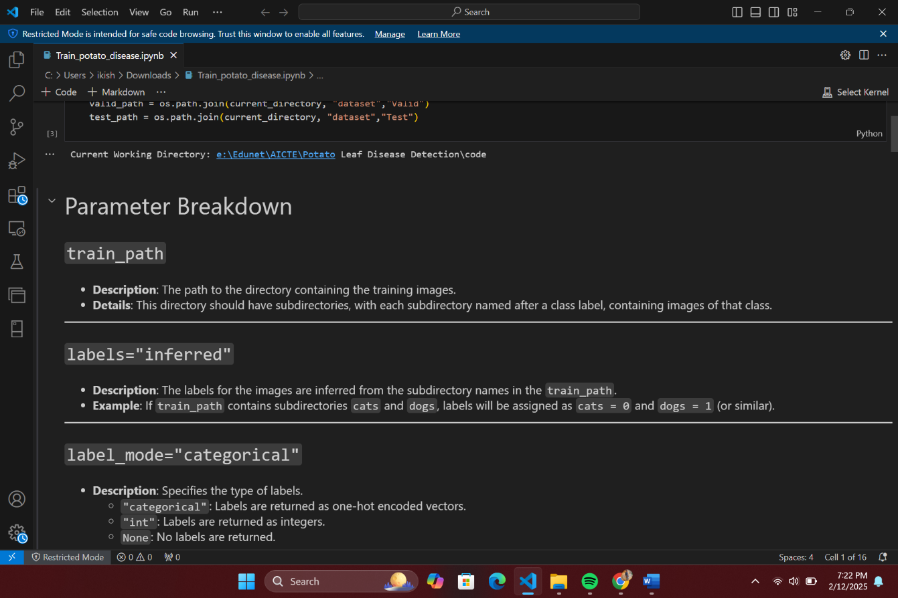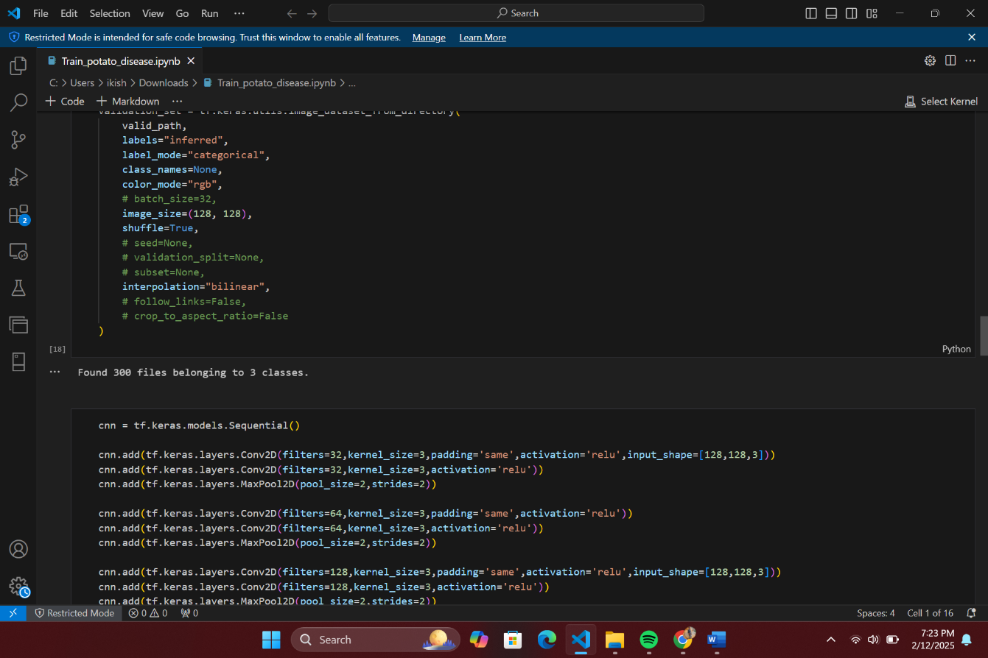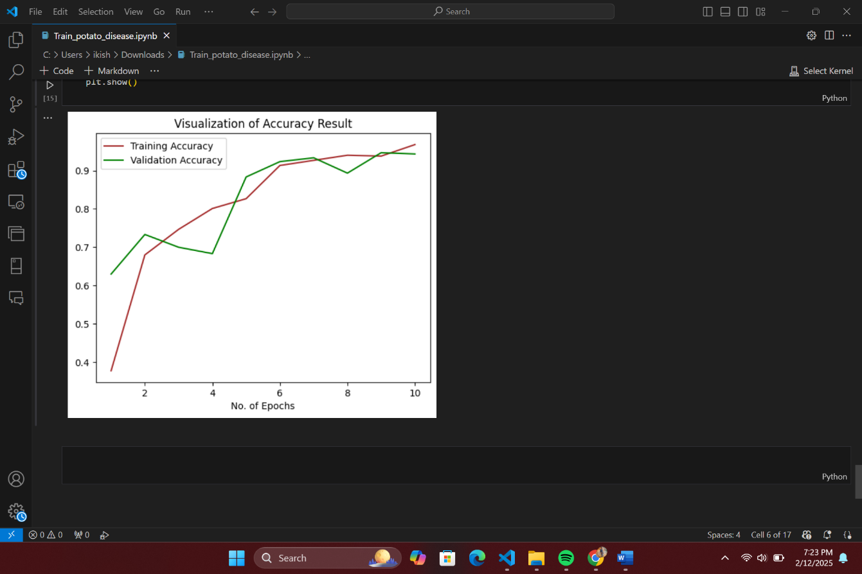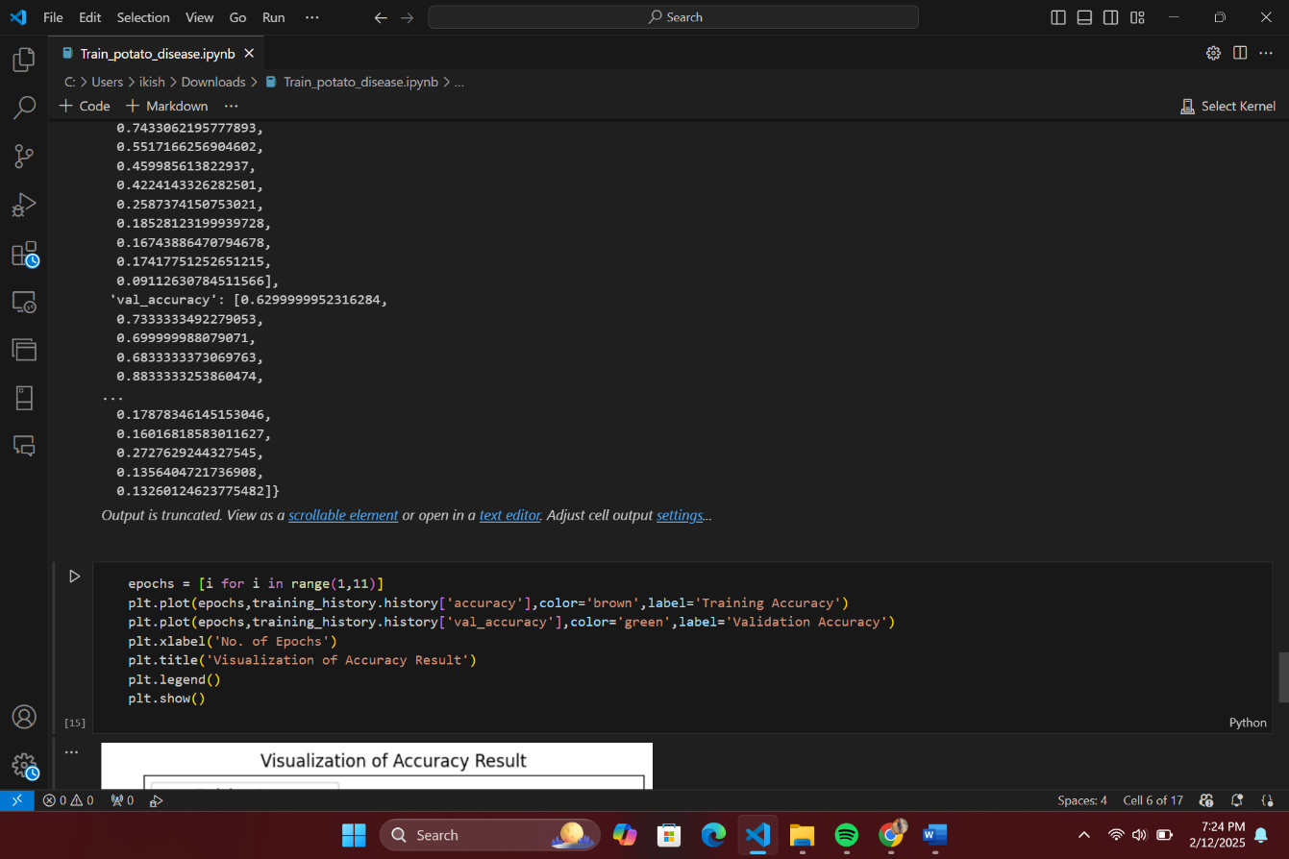
  - GitHub Link for Code:
https://github.com/kkisalwa/AICTE-INTERNSHIP-Potato-leaf-disease-project.git

CHAPTER 5
Discussion and Conclusion

  - Conclusion:
The Potato Leaf Disease Detection System is a powerful AI-driven solution designed to assist farmers, agricultural experts, and researchers in identifying and managing potato leaf diseases efficiently. By leveraging deep learning, image processing, and cloud computing, the system ensures accurate disease classification and provides timely recommendations to improve crop health and yield.
This project addresses the limitations of traditional manual inspection methods, which are often time-consuming, error-prone, and require expert knowledge. With an intuitive mobile and web-based interface, farmers can easily capture or upload images of potato leaves, receive real-time diagnosis results, and access recommended treatments. The system's scalability and adaptability allow it to be deployed across different agricultural regions, benefiting both small-scale and commercial farmers.
Additionally, by integrating IoT devices, drones, and real-time weather data, the system can be further enhanced to provide proactive disease management strategies. Future improvements could include expanding the dataset, improving model accuracy, and incorporating multi-language support to reach a broader audience.
In conclusion, the Potato Leaf Disease Detection System has the potential to revolutionize plant disease management by providing an efficient, cost-effective, and accessible solution. By empowering farmers with AI technology, it contributes to improved agricultural productivity, reduced economic losses, and a more sustainable farming ecosystem. 🌿🚀

REFERENCES

- Ming-Hsuan Yang, David J. Kriegman, Narendra Ahuja, “Detecting Faces in Images: A Survey”, IEEE Transactions on Pattern Analysis and Machine Intelligence, Volume. 24, No. 1, 2002.

